Drawing IB Topo from ibnetdiscover v1.0

**HyungKwang Choi (**[**s99225078@gmail.com**](mailto:s99225078@gmail.com)**, 2023.06)**

Table of Contents

**1. Introduction** 3

**1.1 Revision History** 3

**1.2 Glossary** 3

**1.3 Reference** 3

**2. Overview** 4

**2.1 Running environment.** 5

**2.2 What things different between Brian’s and mine** 5

**2.3 Topology Supported & Tested.** 5

**3. How to run** 8

**3.1 Quick view & How to run** 8

**3.2 “Drawing options for Switches”** 9

3.2.1 Drawing End Host servers 9

3.2.2 Combine ASIC into Directors 10

3.2.3 Put Switch & Director names in Visio boxes 11

3.2.4 Label VISIO inter-switch lines with the # of cables 12

**3.3 “Drawing options for End Host Servers”** 13

**3.4 “Files to create”** 14

**4. Useful features** 15

**4.1 Warning ‘Invalid LID check’** 15

**4.2 Warning ‘Mis-cabling’** 17

# **1. Introduction**

## **1.1** **Revision History**

Table 1 tracks the revision history for this specification.

| Revision | Date | Author | Comments |
| --- | --- | --- | --- |
| 0 | - | Brian Forbes | Initial Draft (Tarzan Text Version + Only drawing Switch) |
| 1.0 | 2023.06.05 | HyungKwang Choi | Tarzan + GUI version + Drawing end Hosts + several features |
|  |  |  |  |

## **1.2 Glossary**

Table 2 lists the terms and acronyms used in this Document.

Table 2: Terminology and Acronyms

| Term | Definition |
| --- | --- |
|  |  |
|  |  |
|  |  |
|  |  |
|  |  |
|  |  |
|  |  |

## **1.3 Reference**

Table 3 lists the reference referred at this Document.

Table 3: Reference

| Subject | Site |
| --- | --- |
|  |  |
|  |  |
|  |  |
|  |  |
|  |  |
|  |  |
|  |  |

# **2. Overview**

Unlike Ethernet, in case IB, there is no tool which draw IB topology except UFM.

UFM itself is not handy and does not draw other customer’s topo.

My thinking started on that point.

Fortunately, there is a guy who had the same thinking and started coding for this earlier.

He is Brian Forbes.

Actually I followed most of his script, and added several useful features on top of his scripts.

* Brian’s script is text based interactive script.

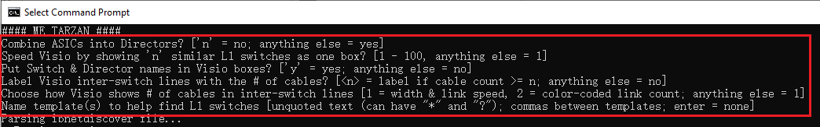

* My script

## **2.1 Script Running/developed environment.**

* Window 10
* Python 3.9.6
* Lib install required : pyqt5

PS C:\Users\hyungkwangc> pip install pyqt5

* Please refer to whole lib installed in my labtop. Most of them are not needed .But just for reference

PS C:\Users\hyungkwangc> pip3 list

Package Version

------------------- ----------

click 7.1.2

contourpy 1.0.7

cycler 0.11.0

et-xmlfile 1.1.0

fonttools 4.39.2

fsspec 2022.5.0

importlib-resources 5.12.0

kiwisolver 1.4.4

matplotlib 3.7.1

numpy 1.22.3

openpyxl 3.0.9

packaging 23.0

pandas 1.4.1

Pillow 9.4.0

pip 21.1.3

ply 3.11

pyasn1 0.4.8

pycryptodomex 3.17

pyparsing 3.0.9

PyQt5 5.15.4

pyqt5-plugins 5.15.4.2.2

PyQt5-Qt5 5.15.2

PyQt5-sip 12.11.1

pyqt5-tools 5.15.4.3.2

pyqtgraph 0.13.2

pysmi 0.3.4

pysnmp 4.4.12

python-dateutil 2.8.2

python-dotenv 0.21.1

pytz 2022.1

qt5-applications 5.15.2.2.2

qt5-tools 5.15.2.1.2

scapy 2.5.0

setuptools 56.0.0

six 1.16.0

XlsxWriter 3.1.0

zipp 3.15.0

## **2.2 What things different between Brian’s and mine**

* Brian’s Tarzan
* Text version.
* It creates only Switch.
* My script
* It succeeded all Brian’s Tarzan codes & functions.
* GUI Version
* It draws End host servers.

1. You can adjust all the options for your own for each nodes (size, font, color, width…and so on)

* Other new features.

1. Checking invalid LID & Mcast LID

2. It warns if end hosts directly connected to L2 or L3 switches

## **2.3 Topology Supported & Tested.**

* You can download/test each ibnetdiscover file corresponding to each Topo.

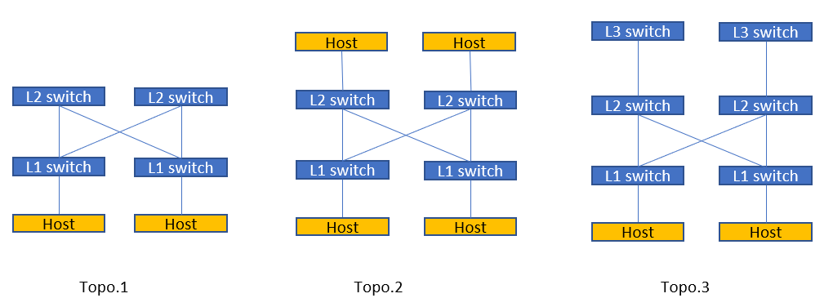

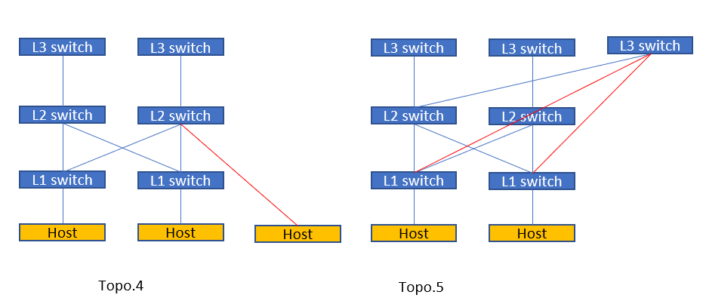

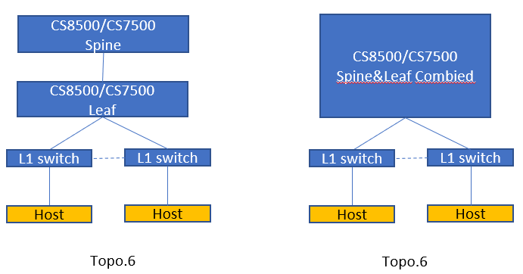

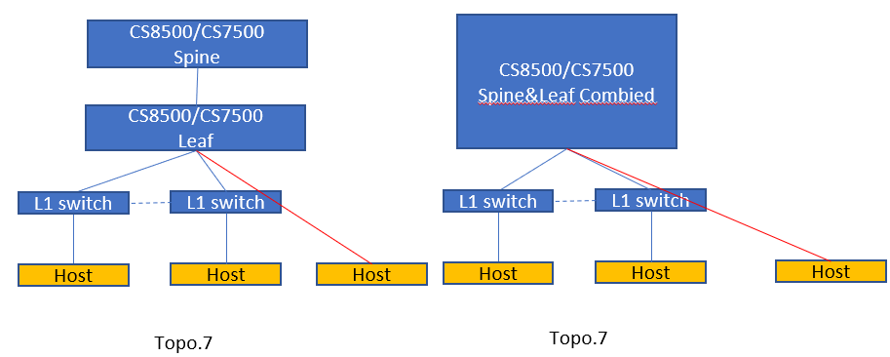

Topo.8_CS8500_invalid_lid.txt, Topo.8 -invalid_lid_Null.txt

# **3. How to run**

## **3.1 Quick view & How to run**

**\*\*\* It’s simple \*\***

Step 0 : simple run the script. If you installed python 3.8+ , pyqt5 lib

C:\Users\hyungkwangc>Drawing IB Topo from ibnetdiscover.py

Step 1: Import “ibnetdiscover” file

Step 2: “Drawing options for switch”

Step 3: “Drawing options for End Host Servers.” If you want to draw end Hosts.

* it’s only activated when you clicked ‘Drawing End Host Server’ button

Step 4: Select “Files to create”, which you want to create

Step 5: Running

* After running, it will create files. In CASE ‘.gv’ file, please open MS Visio, import it

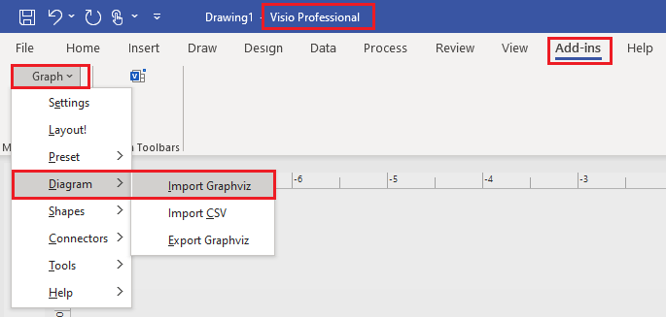

## **3.2 “Drawing options for Switches”**

### 3.2.1 Drawing End Host servers

* If you want to draw End Hosts in Visio, ‘Yes’

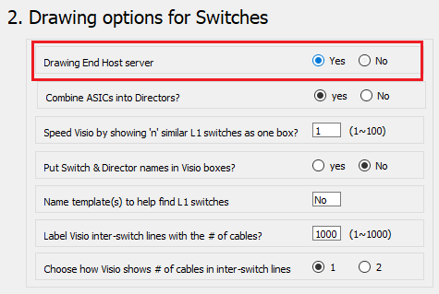

* ‘No‘ ‘ Yes’ : end Hosts are drawn as circle, you can change the shape.

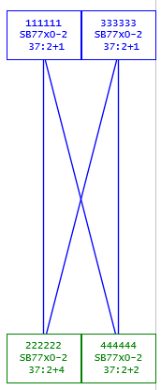 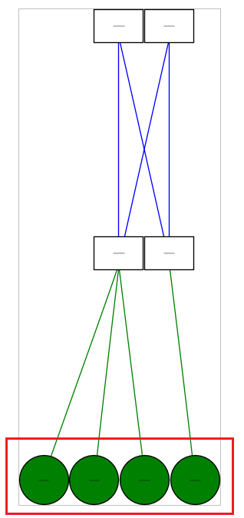

### Combine ASIC into Directors

* In CASE Director switch (ex CS7500, CS8500), It combines Director switch’s Spine & Leaf.

Each Director spine & Leaf are combined & expressed as Dx such as) D1, D2, D3,,,,,

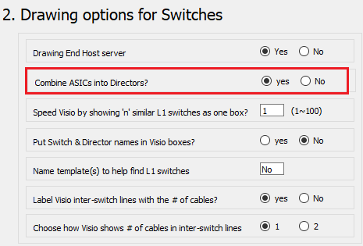

* If you want to draw Spine & Leaf all it’s connections, you can choose ‘No’
* In CASE ‘Yes‘, below

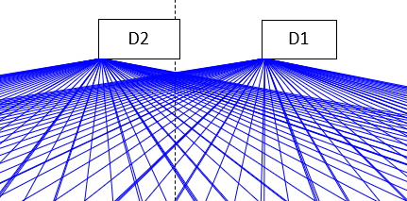

### 3.2.3 Put Switch & Director names in Visio boxes

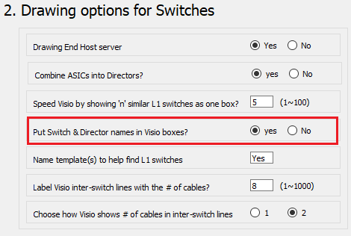

* From “_graphviz.gv”

"98039b03008668a0" [color = blue, fontcolor = blue, fillcolor = white, fontsize = 4, label = "Quantum Mellanox T\nechnologies \n \n8668a0\nQM87x0\n41:19+0 "]

* From VISIO

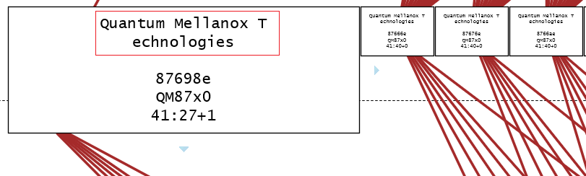

### 3.2.4 Label VISIO inter-switch lines with the # of cables

* It points out and shows how many cables are connected between inter-switches

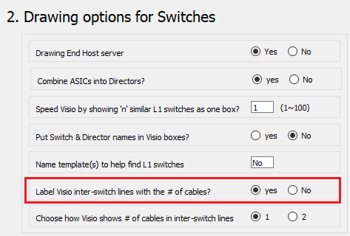

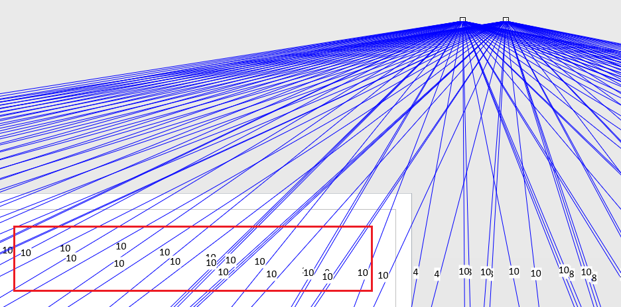

## **3.3 “Drawing options for End Host Servers”**

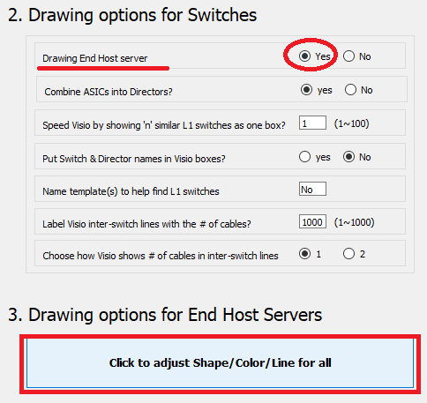

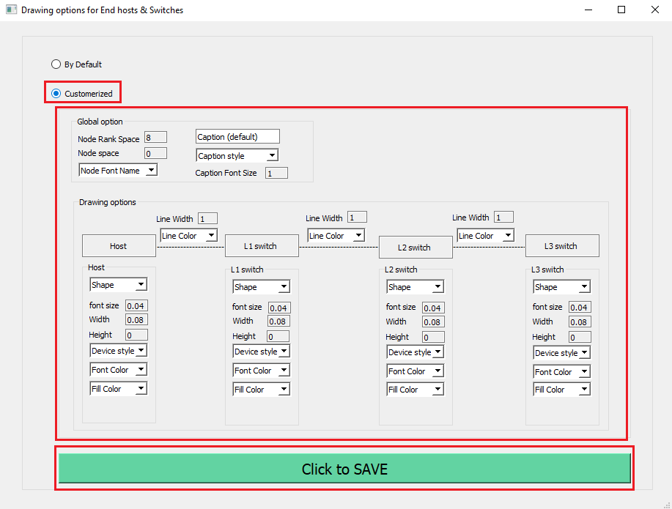

## **3.4 “Files to create”**

* You can select files which you want to create.

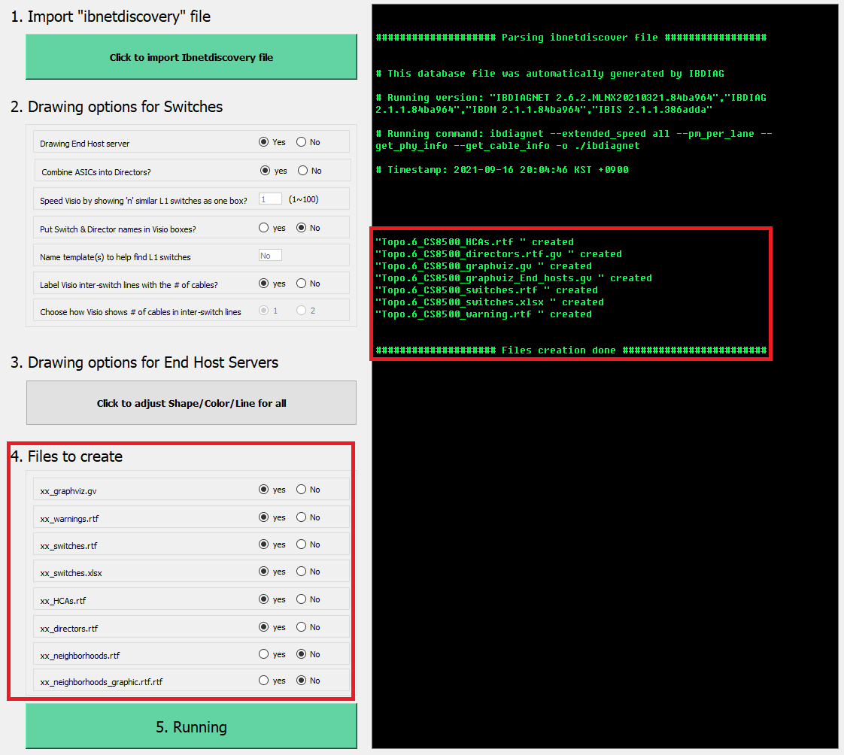

# **4. Useful features**

## **4.1 Warning ‘Invalid LID check’**

* From IBTA spec for LID range.

* If ibnetdiscover has Invalid LID or Mcast LID, it detects and warns like below.

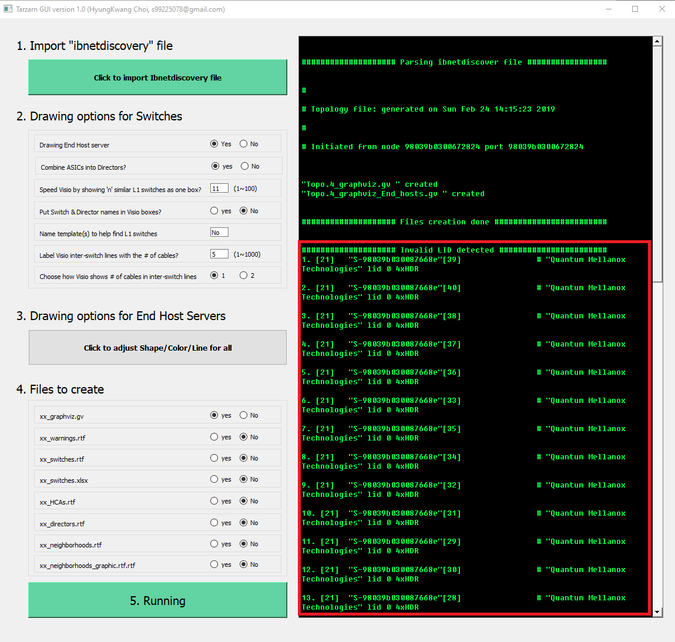

## **4.2 Warning ‘Mis-cabling’**

* If End host server directly connected L2/L3 switches, it warns like below.

That means, your IB topology may have a cable connection problem such as) mis-cabling.

* Lab tested below topo

Ex)

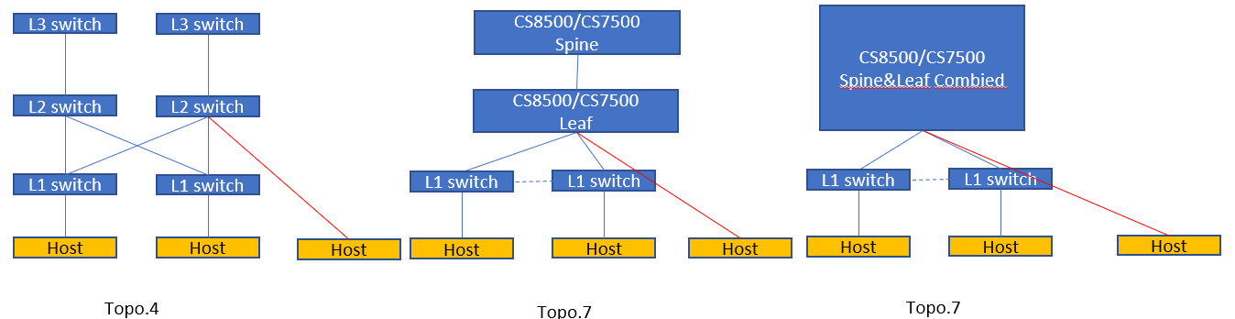

* Warns at running.

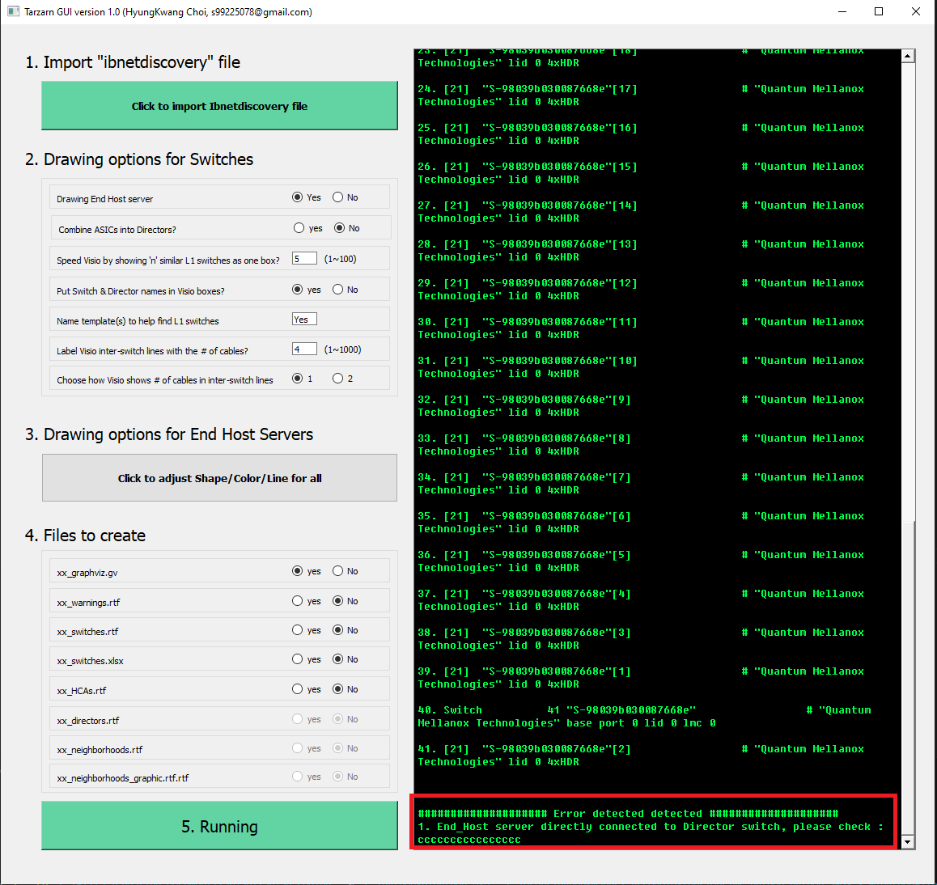

* From VISIO : It red-highlights the host mis-connection

